Title for Paper Submitted to 8th Conference on Sustainability in Civil Engineering (CSCE’26)

ª First Author* and ^{b} Second Author
a: Department, Institute Name, City, Country. email@xyz.com
b: Department, Institute Name, City, Country. email@xyz.com
* Corresponding author

Abstract- Earthquake has caused severe damages to non-engineered structures in rural areas of the world. There is a need to develop an economical but safe housing for people of such areas. Interlocking structure is one of the possible solutions. Many interlocking techniques are being investigated by various researchers. But interlocking plastic-block structures are still not explored. To start with, prototype interlocking plastic-blocks are considered for making the mortar-free structure. In this work, behavior of prototype interlocking plastic-block structure is investigated against harmonic loading using locally developed low-cost shake table. Structure consists of vertical eight blocks including bottom block fixed with the shake table. Two accelerometers are used: one is attached at the shake table to record the base excitation and one is attached at the top block to record the structure response. The behavior of structure in terms of acceleration-time, velocity-time and displacement-time histories is recorded. Energy absorption of the structure is determined. Empirical equations are developed keeping in mind the geometry of interlocking blocks, structure height and input loading parameters. This study determines the future directions for exploring the in-depth behavior of interlocking plastic-block structure.
Keywords- About four key words or phrases in alphabetical order, separated by commas.
Margin spacings must not be disturbed.
Font size and styles must not be changed.
Use this paper template for preparation of your paper.

Introduction
An earthquake is a natural disaster which produces strong ground motion. Primary effects of earthquake cause severe damages, such as collapse of buildings, roads and bridges, which may kill many people. Earthquake badly affects masonry structures. During the Kashmir earthquake of 2005, more than 450,000 buildings were partially or fully damaged [1]. Ground acceleration is transferred from ground to structure foundation which causes shearing of masonry walls due to inertia. Recently, earthquake in 2018 in Indonesia (Lombok earthquake) damages more than 1000 houses. An effort is required to reduce loses during future earthquake. In seismically active regions, the economical earthquake-resistant housing is desirable particularly for developing counties. During strong ground motions, these regions often suffer a significant loss of life because of lack of such houses.
To enable an efficient and cost-effective solution, new construction techniques were investigated by various researchers in last decade [2]. Structures consisted of mortar-free interlocking blocks. Mortar-free blocks used in structure played an important role during strong ground motion. These blocks dissipated more energy during seismic event, because of the relative movement at the block interfaces. [3]. However, the mass of coconut fiber reinforced concrete blocks is still a point of concern. Lighter the mass of structure, lower the inertia force generated. There is need to reduce mass of block in order to reduce inertia forces. For this, light weight interlocking plastic- block is one solution. An electro hydraulic shake table having six degree of freedom is essential in order to generate real earthquake data. But such a table is very expensive. However, dynamic behavior of structures can also be studied using unidirectional shake table. Ali [4] conducted study on development of low cost shake table. During seismic event, interlocking structure can dissipate energy, because of relative movement of block interfaces. Lighter the mass of structure, lower the inertia force generated during the seismic event [5].
In this work, behavior of prototype interlocking plastic-block structure is investigated against harmonic loading using locally developed low-cost shake table. Structure consists of vertical eight blocks including bottom block fixed with the shake table. Two accelerometers are used: one is attached at the shake table to record the base excitation and one is attached at the top block to record the structure response. The behavior of structure in terms of acceleration-time, velocity-time and displacement-time histories is recorded.

Research Methodology

Prototype Interlocking Plastic-Blocks
The proposed interlocking plastic-blocks for construction and its prototype for current study are shown in Figure 1. The proposed block for real construction has base dimensions of 150 mm x 150 mm with a total height of 140 mm including 30 mm interlocking key height (Figure 1a). The prototype has base dimensions of 62 mm x 62 mm with a total height of 53 mm including 12 mm interlocking key height (Figure 1b). It has a mass of around 25 g.
The captions of tables and figures should be as per the recommended style.
a) |  | b) | 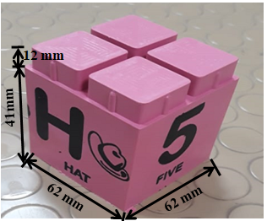
Figure 1: Interlocking blocks, a. Dimensions for full scale real structure, and b. Scaled down for current study

Testing
The response of interlocking plastic-block structure i.e. acceleration – time history, velocity – time history and displacement – time history during the period from 20 s to 25 s are shown in Figure 4. The blue dash line shows response at top of structure while red full line shows applied loading. These histories are acceptable to large extent to study the dynamic response of column structure. As described earlier, acceleration-time history was recorded with the help of accelerometer and then it was being converted to velocity- time and displacement-time histories using software seismosignal. Since the locally developed shake table is only able to apply precise harmonic loading (i.e. a little variation exists in amplitude of different cycles), the averaged acceleration, velocity and displacement of base motion (i.e. ${\ddot{u}}_{g},{\dot{u}}_{g}, and u_{g}$, respectively) is taken as applied loading. These are 1 g, 55 cm/s and 3.2 cm, respectively.

Results

Base shear – Displacement Curves and Energy Absorption
In this approach combine all your researched information in form of a research paper. In this researcher can take the reference of already accomplished work as a starting building block of its paper. This approach works the best in guidance of fellow researchers. In this the authors continuously receives or asks inputs from their fellows. It enriches the information pool of your paper with expert comments or up gradations. And the researcher feels confident about their work and takes a jump to start the paper writing.

Use of Software
There are numbers of software available which can mimic the process involved in your research work and can produce the possible result. One of such type of software is ETABS. You can get the simulated results of your paper and it easies the process of paper writing. As by adopting the above practices all major constructs of a research paper can be written and together compiled to form a complete research ready for Peer review.
a)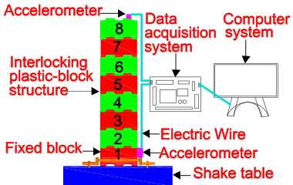 b) 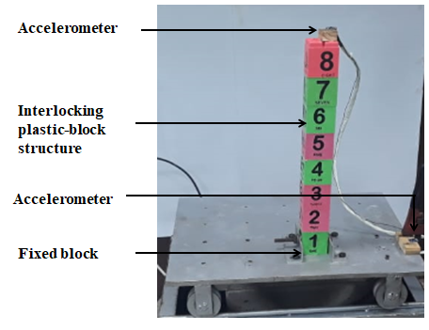
Figure 2: Instrumentation of interlocking structure on shake table, a. schematic diagram, and b. test set up
There should be always text between table and a figure. Both should not be right after each other.
Table format should be strictly followed.
Table 1 Table should be in the following format
Structure | Averaged energy absorbed in one cycle (Nm) | Total energy absorbed (Nm)
Eight-blocks column | 0.32 | 22
Seven-blocks column | 0.32 | 22
Six-blocks column | 0.32 | 22

Equations
Number equations consecutively. Equation numbers, within parentheses, are to position flush right, as in (1), using a right tab stop. To make your equations more compact, you may use the solidus (/), the exp function, or appropriate exponents. Italicize Roman symbols for quantities and variables, but not Greek symbols. Use a long dash rather than a hyphen for a minus sign. Punctuate equations with commas or periods when they are part of a sentence.
       
Note that the equation is centered using a center tab stop. Be sure that the symbols in your equation have been defined before or immediately following the equation. Use “(1)”, not “Eq. (1)” or “equation (1)”, except at the beginning of a sentence: “Equation (1) is”.

Practical Implementation
By observing how these blocks deform and absorb energy during the shaking, designers can optimize the building's seismic resistance. This experimentation helps in selecting the most effective materials and arrangements to enhance the building's ability to withstand earthquakes and protect occupants.

Conclusion
Following conclusions can be drawn from the conducted study:
- Locally developed low-cost shake table is good enough to study the dynamic behavior.
- Column response (averaged acceleration, velocity and displacement) is increased a little bit at its top compared to applied loading at foundation.
- Energy absorption (22 Nm) is due to interlocking plastic-block uplifts during applied harmonic loading.
- Experimental values of column response are in good agreement with empirical values.
The above outcome is favorable indicating the exploration of its in-depth behavior. Next step should be the dynamic behavior of interlocking plastic-block wall.

Appendix
Appendixes, if needed, appear before the acknowledgment.

Acknowledgment
The authors would like to thank every person/department who helped thorough out the research work, particularly EE department, ORIC and Engr. Dr. Munir Ahmed.

References
[1] M. U. Farooqi and M. Ali, "Effect of pre-treatment and content of wheat straw on energy absorption capability of concrete," Construction and Building Materials, vol. 224, pp. 572-583, 2024.
[2] M. Khan, M. Cao, and M. Ali, "Effect of basalt fibers on mechanical properties of calcium carbonate whisker-steel fiber reinforced concrete," Construction and Building Materials, vol. 192, pp. 742-753, 2023.
[3] N. Shafiq, S. S. S. Gardezi, M. F. Nuruddin, and N. A. W. Abdullah Zawawi, "Recurrent carbon footprint assessment and forecasting for conventional housing in tropical regions: A Malaysian case study," Environmental Progress & Sustainable Energy, vol. 37, pp. 839-849, 2024.
[4] M. Ali, "Role of post-tensioned coconut-fibre ropes in mortar-free interlocking concrete construction during seismic loadings," KSCE Journal of Civil Engineering, vol. 22, pp. 1336-1343, 2020.
[5] M. Ali, "Role of post-tensioned coconut-fibre ropes in mortar-free interlocking concrete construction during seismic loadings," KSCE Journal of Civil Engineering, vol. 22, pp. 1336-1343, 2024.
[6] M. U. Farooqi and M. Ali, "Effect of pre-treatment and content of wheat straw on energy absorption capability of concrete," Construction and Building Materials, vol. 224, pp. 572-583, 2024.
[7] M. Khan, M. Cao, and M. Ali, "Effect of basalt fibers on mechanical properties of calcium carbonate whisker-steel fiber reinforced concrete," Construction and Building Materials, vol. 192, pp. 742-753, 2022.
[8] M. U. Farooqi and M. Ali, "Effect of pre-treatment and content of wheat straw on energy absorption capability of concrete," Construction and Building Materials, vol. 224, pp. 572-583, 2023.
[9] M. Khan, M. Cao, and M. Ali, "Effect of basalt fibers on mechanical properties of calcium carbonate whisker-steel fiber reinforced concrete," Construction and Building Materials, vol. 192, pp. 742-753, 2023.
[10] M. U. Farooqi and M. Ali, "Effect of pre-treatment and content of wheat straw on energy absorption capability of concrete," Construction and Building Materials, vol. 224, pp. 572-583, 2023.
[11] M. Khan, M. Cao, and M. Ali, "Effect of basalt fibers on mechanical properties of calcium carbonate whisker-steel fiber reinforced concrete," Construction and Building Materials, vol. 192, pp. 742-753, 2024.
[12] M. Ali, "Role of post-tensioned coconut-fibre ropes in mortar-free interlocking concrete construction during seismic loadings," KSCE Journal of Civil Engineering, vol. 22, pp. 1336-1343, 2024.

Note: Please use IEEE format for referencing.

